Service-Learning Handbook
www.gcsnc.com 2023-2024

TABLE OF CONTENTS

Why Service-Learning? 1
Social Emotional Learning and Character Education Team 2
Character Education and Service Learning: An Overview 3
Examples of Service-Learning 4
Service-Learning Diploma and Awards 5-6
Important Dates and Information 7
GCS Teachers: Using Service-Learning as a Teaching Strategy
in Classrooms and Clubs 8
Service-Learning Teacher Documentation Form 9
Service-Learning: Addressing Community Needs 10
What Qualifies for the High School Service-Learning Awards Program? 11
Service-Learning Expectations 12
Service-Learning Experience Student Process 13
Service-Learning Approval Form 14-15
Service-Learning Student Log 16
High Quality Student Reflection 17
Service-Learning Reflection Form 18
Service-Learning Appeal Form 19
x2VOL 20-21
Did You Know? 22

WHY SERVICE-LEARNING?

Dear Friends,

It is the mission of GCS that every student receives a world-class education and leaves prepared to succeed in the college or career of their choice. One proven way of achieving that mission is through character development and service-learning.

Students involved in service-learning are far more likely to become civic minded and involved in their community years after they graduate. They also improve their social and personal skills, the “essential” or “soft skills” we hear so many employers say they look for in potential employees. We must engage students and give them opportunities to work alongside others. Service-learning, when done well, accomplishes this.

The district is implementing social emotional learning as a framework to support and build on the work being done through character development and service learning. Social emotional learning is the process through which children and adults understand and manage emotions, set and achieve positive goals, feel and show empathy for others, establish and maintain positive relationships and make responsible decisions. As we strengthen these skills throughout our classrooms and buildings, we expect to see a greater focus on serving others, as well as increased student achievement and improved behavior.

Our district is dedicated to transforming learning and life outcomes for all students, and service-learning is one important way we can help do that. Thank you for your participation, and I look forward to the great things you will do through this process.

WHY DISTRICTS, SCHOOLS, AND CLASSROOMS SHOULD PRACTICE SERVICE-LEARNING

- Service-Learning leads to engagement and effective instruction.

- Service-Learning helps academic improvement and higher order thinking skills.

- Service-Learning fosters the development of important personal and social skills.

- Service-Learning develops stronger ties to schools, communities and society.

- Service-Learning promotes exploration of various career pathways.

- Service-Learning is associated with positive school environments.

- Service-Learning is associated with more community support for schools.

Source: RMC Research Corporation. (2007). “Why districts, schools, and classrooms should practice service- learning.” Scotts Valley, CA: National Service-Learning Clearinghouse. Retrieved from: http://servicelearning. org/instant info/factsheets/k-12_facts/why/

The Social Emotional Learning and Character Education team supports the growth and implementation of social and emotional learning through current researched practices. Character Education and Service Learning are strong factors in the growth of social and emotional learning.

If you are a community partner and have questions regarding Service-Learning in Guilford County Schools (GCS), please contact the GCS Social Emotional Learning and Character Education Department. We strive to support and foster relationships with community members while they help our students grow through service learning. You may register as a non-profit organization on x2VOL.com. We look forward to working with you.

If you are a student, parent, or school staff and have questions regarding Service-Learning in Guilford County Schools (GCS), please contact Jay Cameron, cameroj2@gcsnc.com.

Service-Learning Office

120 Franklin Blvd.
Greensboro, NC 27401
Phone: (336) 370-8191(press one)
Fax: (336) 370-2320

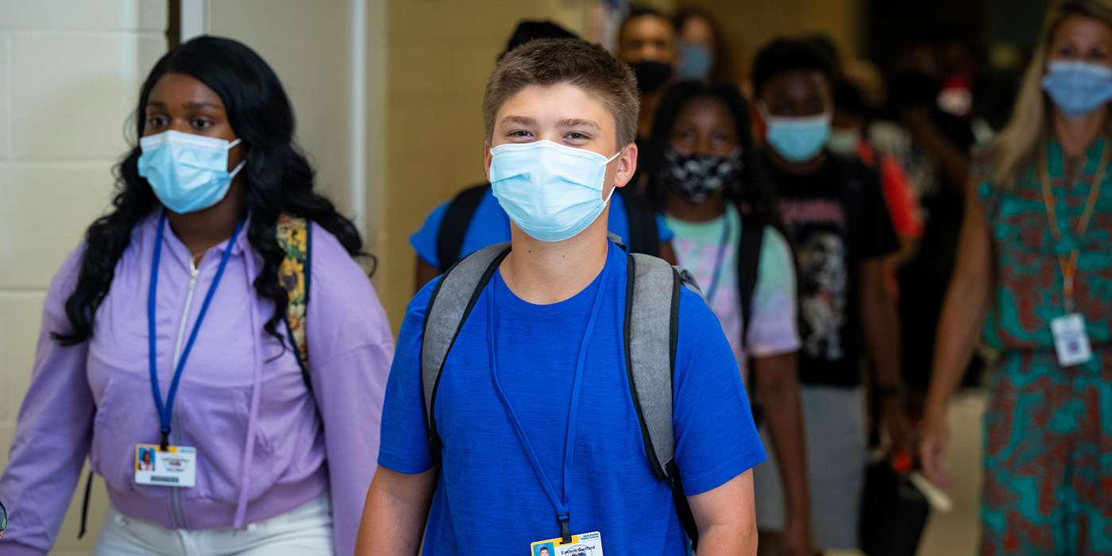

Social Emotional Learning and Service Learning: An Overview

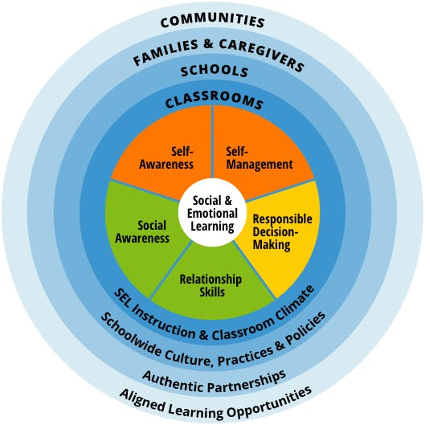

Guilford County Schools (GCS) partnered with The Collaborative for Academic, Social, and Emotional Learning (CASEL) in 2019.

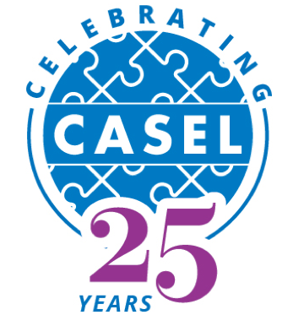

Guilford County Schools (GCS) understands the importance and the benefits of providing students with understanding and opportunities when it comes to Social Emotional Learning and Service Learning. Social Emotional Learning and Service Learning go together hand in hand to develop students into successful community members.

What is Social Emotional Learning?

SEL is the process through which all young people and adults acquire and
apply the knowledge, skills, and attitudes to develop healthy identities,
manage emotions and achieve personal and collective goals, feel
and show empathy for others, establish, and maintain supportive
relationships, and make responsible and caring decisions.

What is Service-Learning?

A way of teaching and learning that connects positive and meaningful action in the community with academic learning, personal growth and civic responsibility. Service-Learning helps develop citizenship and good character while providing direct connections to the academic curriculum. Service-Learning experiences allow students to apply their Social and Emotional skills into action.

Service Learning: Breakdown

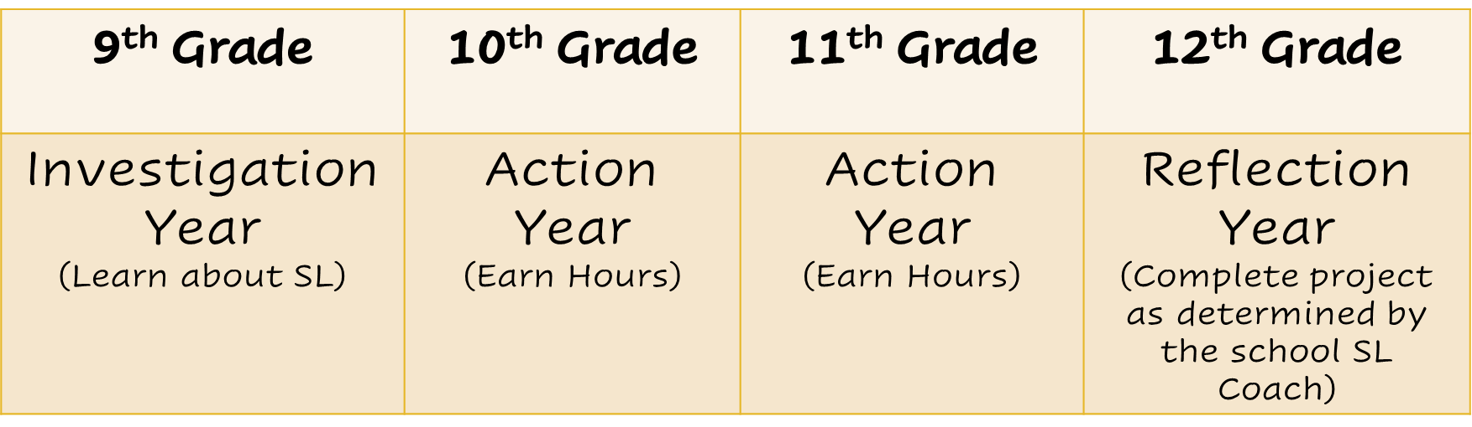

Service Learning: Recognition

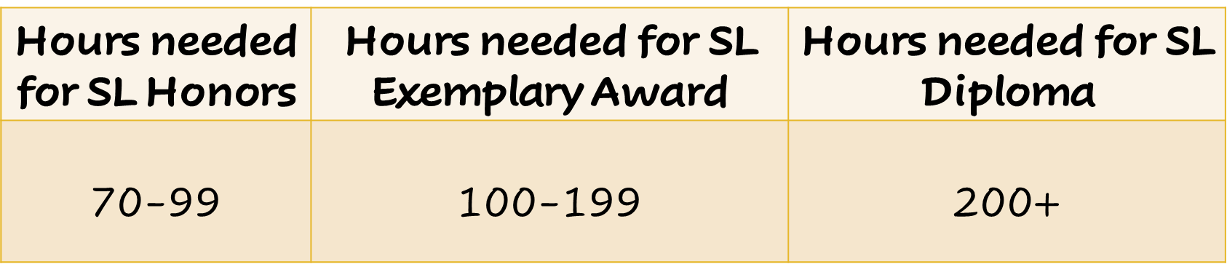

*These guidelines do not apply to OCS/Adaptive Students

EXAMPLES OF SERVICE-LEARNING

Service-Learning is more than just simple volunteering. In the process of service to their school and/or community, students learn a lot about themselves
and their responsibilities as a citizen while making connections with what they are learning in schools.

Service-Learning: EXAMPLE 1

- Coordinating a community marathon is service.

- Measuring body mass index is learning.

To give real service you must add something which cannot be bought or measured with money, and that is sincerity and integrity.”
“

Douglas Adams

- Calculating the average BMI of a school, setting up a website to gather statistics, then organizing a “Walk across North Carolina” to help reduce obesity is service learning.

Service-Learning: EXAMPLE 2

- Picking up trash on a riverbank is service.

- Studying water samples under a microscope is learning.

- Science students collecting and analyzing water samples, documenting
their results and presenting their findings to a local pollution control agency is service learning.

* Adapted from National Youth Leadership Council (http://www.nylc.org/)

How Students Engage in Service-Learning

- Students can participate in service-learning experiences through
GCS classes/clubs. GCS staff should complete a Teacher Documentation Form found on x2vol.

- Students can participate in service-learning experiences independently through non-profit community-based service-learning projects. Students should complete the Service-Learning Approval Form found on x2VOL.

SERVICE-LEARNING DIPLOMA

SERVICE-LEARNING DIPLOMA REQUIREMENTS

The Service-Learning Diploma is a locally developed, official recognition program designed to recognize high school students who are committed to serving their community. Students who complete a minimum of 200 hours of service- learning experience over the course of their high school years will receive this certification upon graduation.

- The program is designed to recognize students who dedicate a significant amount of time to service- learning to address challenges and solve problems in the community.

- All students who complete this program will be awarded a GCS Service-Learning Diploma. Additionally, at graduation, these students will be distinguished by wearing a Service-Learning cord.

Hours must be submitted within the semester that they are completed. Hours completed from June-December must be entered into x2vol by end of December. Hours completed from January-May must be entered by the end of May. SL Approval Forms must be submitted within the semester that service is started with the organization and should be submitted prior to beginning service.

Students entering GCS at any time after their 9th grade year will still be required to complete a minimum of 250 service hours to be eligible for the Service-Learning Diploma. Documented and verifiable Service-Learning hours that meet the program criteria completed in school districts outside of Guilford County will count towards the Service-Learning Diploma and Service-Learning Exemplary Award.

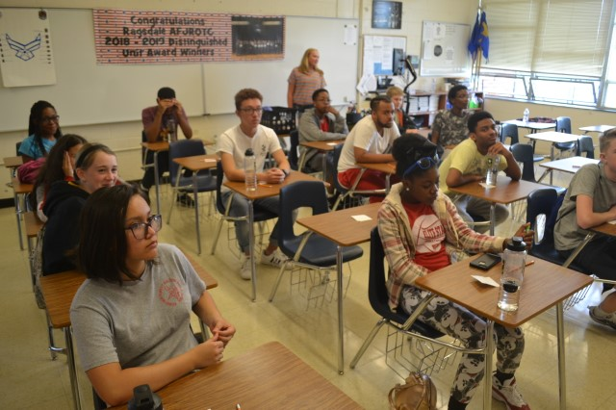

Service-Learning Exemplary Award

SERVICE-LEARNING EXEMPLARY AWARD REQUIREMENTS

The Service-Learning Exemplary Award is an honor GCS high school student may receive upon graduation. This award recognizes students who have devoted a minimum of 100 hours of service-learning experience in their community throughout their high school years.
Graduates are required to complete 100 hours of service to receive the Service-Learning Exemplary Award

While there is no set number of hours to be earned in any school year, as a time management tool, we recommend the following schedule as a guide.

Suggested schedule to acquire the 100 hours of Service-Learning Exemplary Award.

FOR BOTH SERVICE-LEARNING DIPLOMA AND SERVICE-LEARNING EXEMPLARY AWARD: Students may begin documenting hours beginning the first day of summer after the completion of their 8th grade year and may continue their work during the following years. Students may talk with their guidance counselors or contact their high schools with any questions.

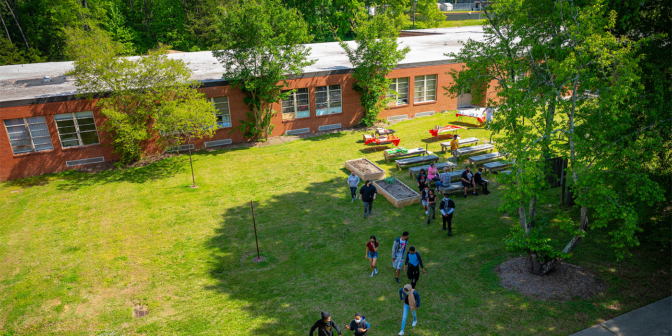

HIGH SCHOOL SERVICE-LEARNING PROGRAM
IMPORTANT DATES AND INFORMATION

The vision of the Social Emotional Learning and Character Education team is for Guilford County Schools’ students to lead and learn with strong character. One of the Strategic Plan’s goals is to provide our students with the tools and motivation necessary to positively impact our world. Thus, at Guilford County Schools, we offer the following awards to students who answer this challenge:

- Service-Learning Diploma

- Service-Learning Exemplary Award

Submit all Teacher Documentation Forms for all service-learning projects completed during the school year
for freshmen, sophomore or junior classes no later than the last day of school on x2VOL.

END OF 1ST SEMESTER

All students submit Service-Learning Approval Forms for all previous summer hours to their school supervisor.

Graduating Seniors

3rd Wednesday in March (3/20/24) – FINAL submission for all Service-Learning Approval Forms
1st Wednesday after Spring Break (4/17/24)– FINAL submission for all service-learning hours and Teacher Documentation Forms for seniors into x2VOL.

Sophomores, Juniors
As you continue to engage in service-learning, please submit all service-learning approval forms online to your counselor and enter your hours into x2VOL.

STUDENT SERVICE-LEARNING APPEAL PROCESS

All parent and/or student concerns regarding deadlines and other issues other
than the rejection of Service-Learning Approval Forms must be submitted in writing to the Service-Learning Coach at your school. This form and additional documentation will be reviewed by school personnel and GCS district staff if needed. This document can be found on page 19 within this handbook and online.

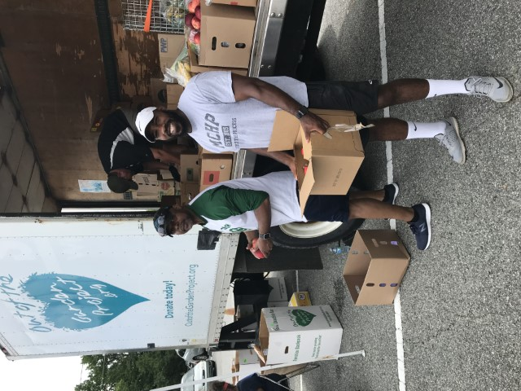

GCS STAFF: USING SERVICE-LEARNING

AS A TEACHING STRATEGY IN CLASSROOMS AND CLUBS
If you are a teacher or club sponsor for Service-Learning activities, here is what
you need to do:

- Plan a quality Service-Learning experience that:

Connects to National Youth Leadership Council’s (www.nylc.org) K-12 Service- Learning Standards for Quality Practice listed below:

- | Meaningful Service | - Link to Curriculum
- | Diversity | - Reflection
- | Youth Voice | - Partnerships
- | Progress Monitoring | - Duration and Intensity

- Facilitate your students’ participation in a quality service-learning experience through Investigation, Preparation & Planning, Action, Reflection, and Demonstration (IPARD).
Allows students to participate in the following five components of quality service- learning:
- Investigation: Identify a need or area of interest in their school or community

- Preparation and Planning: Engage in planning, implementation, and evaluation processes
- Action: Begin the act of service

- Reflection: Reflect on the experience before, during, and after

- Demonstration: Share their experience with family, friends, school and/or community

- Register the Service-Learning experience by:

Completing and submitting the Service-Learning Teacher Documentation Form via email to the Service-Learning Teacher Leader contact at your school before engaging youth in a service-learning experience.

Students can earn hours for time spent in preparing and planning as well as time in service.

You should receive an email from the Teacher Lead verifying that your documents have been received and approved.

Once the Teacher Documentation Form is received by the approved, create an Opportunity on x2VOL within your school’s community.
This will allow students to track hours.

GCS SERVICE-LEARNING
TEACHER DOCUMENTATION FORM
Youth voice and choice drives the service-learning experience Turn in to your Service-Learning School representative.

SCHOOL: DURATION OF SERVICE-LEARNING EXPERIENCE:
o WEEK o MONTH o SEMESTER o YEAR

TEACHER(S)/CLASS/CLUB: GRADE LEVEL: NO. OF STUDENTS:

- Themes that apply to service-learning. (Check all that apply):

o Animals
o Community Renewal
o Education
o Elders
o Environment
o Health and Nutrition
o Immigration
o Poverty
o Safety
o Other

- What is the overall purpose for this service-learning experience?
- What books were integrated into this service-learning experience?

GUIDING PRACTICES FOR SERVICE-LEARNING
LINKS TO CURRICULUM: Which curriculum standards/knowledge and skills will be advanced through this service-learning experience?
CHARACTER EDUCATION: Which intrinsic character traits are highlighted in this service-learning experience? (Kindness, Respect, Integrity, etc.)
MEANINGFUL SERVICE: How can this service be personally significant to the youth and community?
RECIPROCAL PARTNERSHIPS: How do students gain career opportunities, communication skills, and understand the vantage points of others in a way that benefits everyone?
RESPECT FOR DIVERSITY: What opportunities are available for youth to experience and explore different backgrounds and replace stereotypes/ biases with accurate information and honor the community?
MONITOR PROGRESS: How do students observe and measure change over time?
I.P.A.R.D.
INVESTIGATION: Do students substantiate a need using media, interviews, surveys and observations?
PREPARATION/PLANNING: How did students deepen understanding and use their knowledge and skills to prepare for action?
ACTION: Will students engage and/or research services as they make local and global connections?
REFLECTION: How do students express their thoughts and feelings using diverse approaches and modalities?
DEMONSTRATION: How do students share what they learned, how they learned and what they accomplished with an appropriate audience?

21st Century Learning Skills youth will develop through this experience (check all that apply):

o Accountability
o Asking Questions
o Communication/Collaboration
o Creativity/Innovation
o Critical Thinking/Problem Solving
o Flexibility/Adaptability
o Initiative
o Leadership
o Social/Cross Cultural Skills
o Writing

Submission Date:

SERVICE-LEARNING: ADDRESSING COMMUNITY NEEDS
WHAT QUALIFIES?

Let’s Get Started!

Students engaged in a service-learning experience should refer to the wheel below before submitting a Service-Learning Approval or Teacher Documentation form.

What real world need do you care about? Make sure your hours make a difference. Please refer to the wheel below to discover what possible community needs you can address through service-learning.

Remember it’s about the service and the learning.
If...
your service is for
a worthy cause

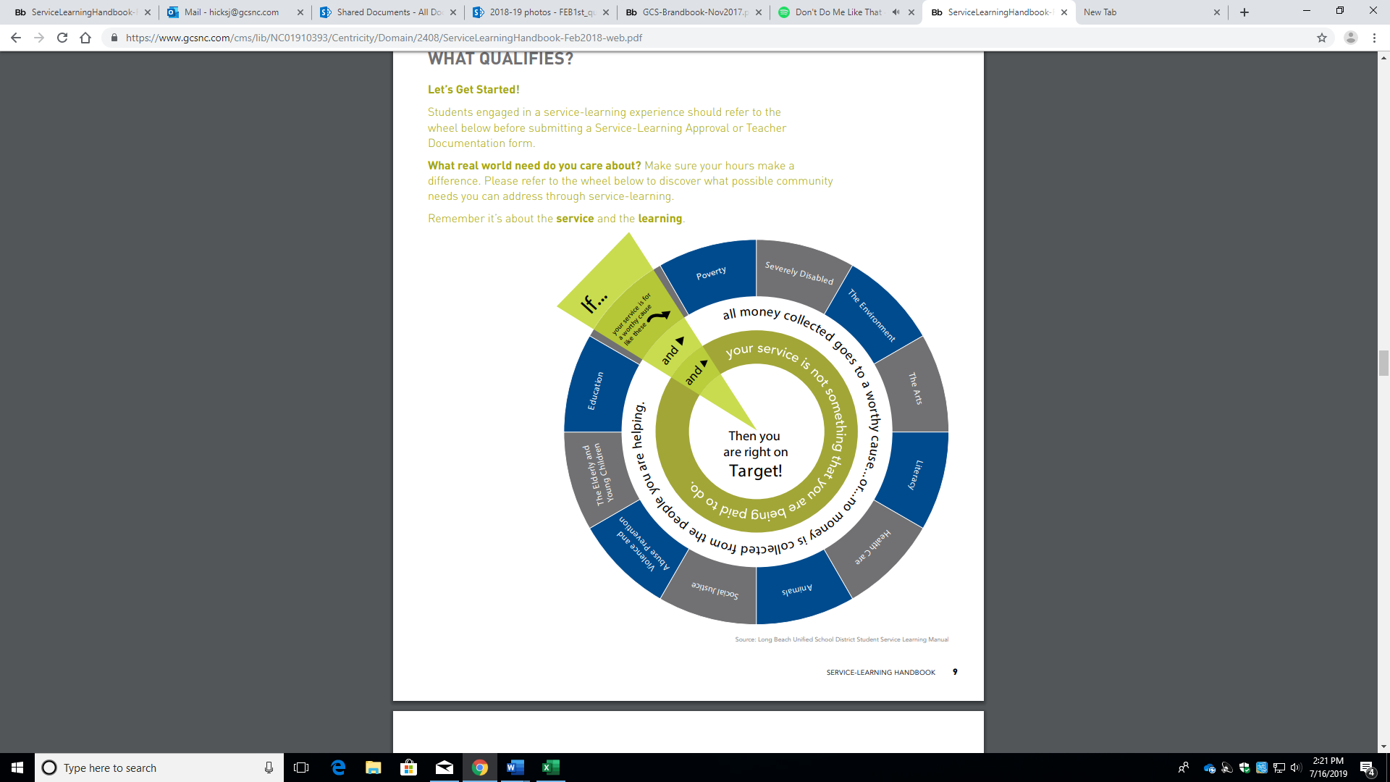

SERVICE-LEARNING HOURS:
Service
WHAT QUALIFIES?
BEGIN YOUR INVESTIGATION WITH COMMUNITY NEEDS AND ISSUES (GO TO PAGE 9). For more information on what is and what is not service learning please check the GCS website.

 | DOES EARN SERVICE HOURS
For Profit | - Shadowing  - Administrative Assistant Tasks.  - Internship
Religious and Faith Based Organizations | - Feeding the Homeless  - Administrative Aid  - Assisting in the nursery/ providing childcare  - Camps and Tutoring  - Tech Services
Childcare and  Elder-care Services | - Childcare services at agencies  - Elder care services at agencies
School Clubs | - Regular club meetings  - Fundraising for the club treasury, uniforms, field trips, etc.  - Helping with club meetings
Sports, Performing Arts and ROTC | - Camps or classes that charge tuition*  - For-profit camp or business*  - Color Guard – Parades
Court Mandated | Court mandated hours count towards service-learning hours. Please contact the Service-Learning Coordinator for more details.
Politics | No political activities will count.
Animals | *Students must seek approval from school-based service-learning coach and submit in writing what they will do at the agency PRIOR to starting.
Source: Adapted from the Long Beach Unified School District Student Service-Learning Manual

SERVICE-LEARNING HOURS:
Service
WHAT QUALIFIES?
BEGIN YOUR INVESTIGATION WITH COMMUNITY NEEDS AND ISSUES (GO TO PAGE 9). For more information on what is and what is not service learning please check the GCS website.

 | DOES NOT EARN SERVICE HOURS
For Profit | *Students must seek approval from school-based service-learning coach and submit in writing what they will do at the agency PRIOR to starting.
Religious and Faith Based Organizations | - Recruitment/ membership building  - Teaching about an organization (The goal is for you to perform charitable and service-learning work, not just talk about it!)  - Vacation Bible School  - Rehearsals (choir, church, plays, etc.)  - Participating in a religious activity  - Assisting/ teaching Sunday School
Childcare and  Elder-care Services | - Babysitting for family, friends, or neighbors
School Clubs | - Activities that benefit only you  - Activities that benefit only the club  - Recruitment/ membership building
Sports, Performing Arts and ROTC | - Ticket profit goes to club
Court Mandated | Please see previous page.
Politics | - Protests/strikes/rallies  - Work for political candidates or parties or special interests
Animals | Please see previous page.
Source: Adapted from the Long Beach Unified School District Student Service-Learning Manual

SERVICE-LEARNING EXPECTATIONS

EXPECTATIONS OF PARENTS

- Help your child select an agency/organization/club that will provide him/her an opportunity to positively impact his/her community through service.

- Sign the Service-Learning Approval Form and, if necessary, assist your child in obtaining a signature from the agency/organization/club.

- As your child participates in the service, discuss with him/her what he/she
is doing; how it relates to what he/she is learning in school and how it is helping to make positive changes in the community.

No act of kindness, no matter how small, is ever wasted.”
“

Aesop

- Parents are unable to verify their own student’s hours. If the parent is the advisor of an organization, then an assistant to the program is responsible for verifying the student’s service-learning hours.

EXPECTATIONS OF SERVICE-LEARNING PROVIDERS

- Give the student an opportunity to participate in the planning of his/her service-learning experience.

- Provide a safe and engaging experience.

- Report any major issues or incidents of inappropriate behavior to the Character Development Office.

- Accurately record the number of hours the student engages in the service in order to verify student hours.

- Help the student reflect on the impact of his/her service before, during and after the service-learning experience (see pages 16-17 for more information about Reflection).

- Advocate for other organizations to engage students in service-learning experiences.

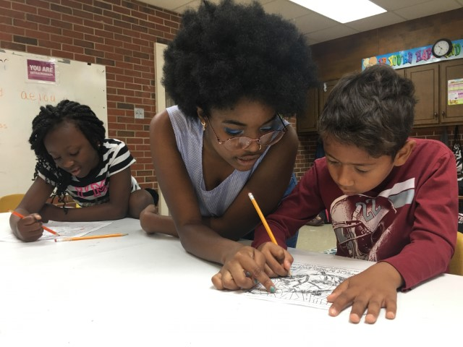

SERVICE-LEARNING STUDENT PROCESS EXPERIENCE

In quality Service-Learning experiences, students participate in the following five components: This process will help students create their community-based service-learning project and complete the Service-Learning Approval Form that is submitted on x2VOL.

Investigation
- Identify a need or area of interest in your school or community (consult the wheel on page 9 of this handbook to stay on track).
- Discuss what you would like to do with your parents and get approval.
- Contact a Service-Learning Provider (this could be a community agency, an organization, a club or a teacher advisor) who currently addresses the need or area of interest you have identified to gather additional information.

Preparation and Planning
- Work with your selected Service-Learning Provider to identify specific duties that would be expected of you.
- Complete the Service-Learning Approval Form

Action
- Begin the change in your school and community.
- Continue your reflections throughout your time of service.
- Get started in x2VOL to track your hours (instructions on page 20-21).
Reflection
- Document your reflections before, during and after the service.
- Choose unique ways to reflect throughout the service. (Example(s): Create a mural/scrapbook, make a video, write a poem, keep a journal or complete the Service-Learning Reflection form.)
- Discuss your reflection activity with the Service-Learning Provider at the end of your service.

Demonstration
- Share your experience with your family, friends, school, house of worship, community or elected officials.

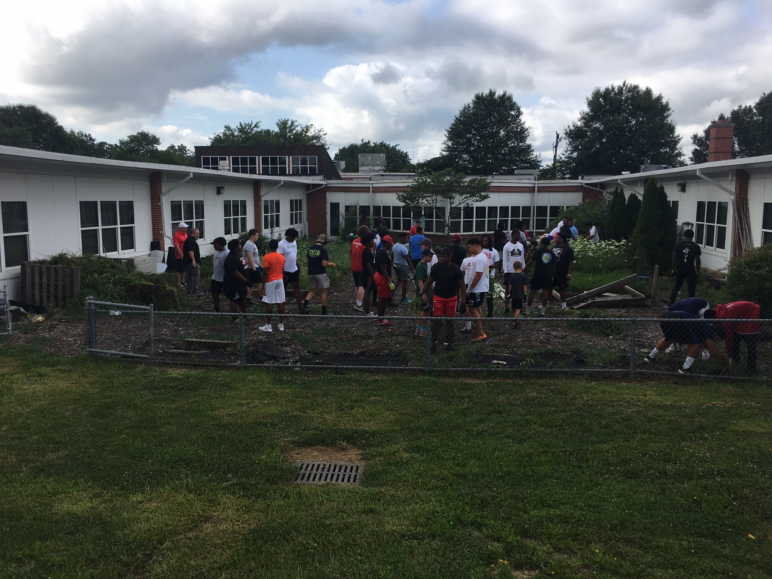

SERVICE-LEARNING APPROVAL FORM

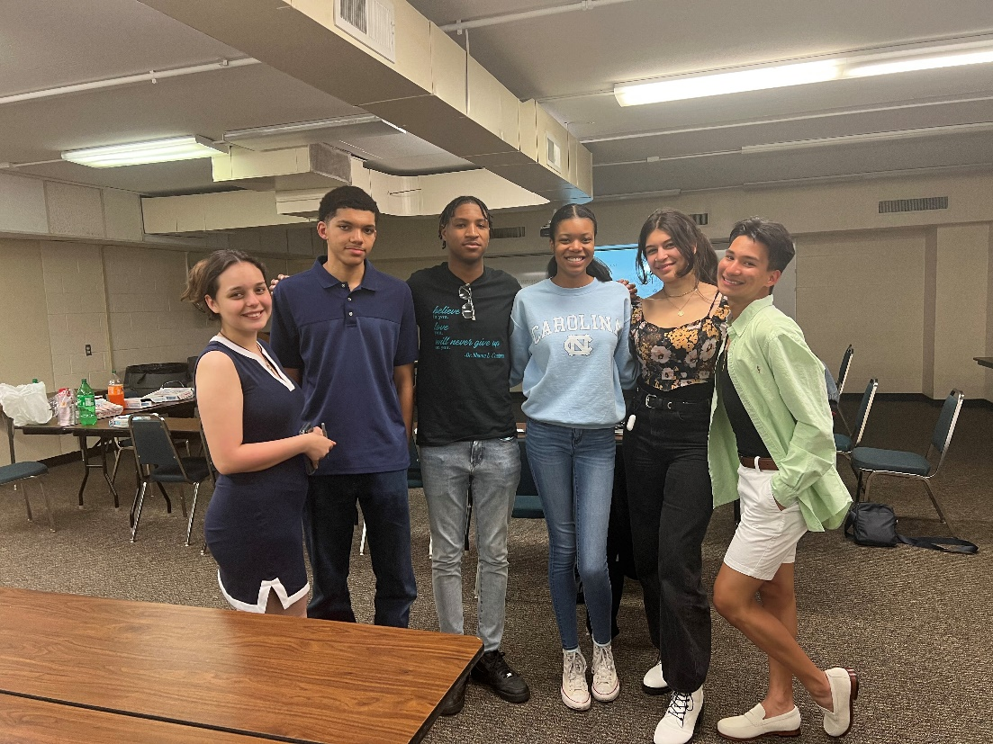

Starting June 15, 2023, students will fill out service-learning approval forms via X2VOL. The student will see a link that guides them to the service-learning approval form. The link will be located on your homepage of X2VOL. In addition, students can find the link on their school’s service-learning Canvas page. If you have trouble finding this information, please contact your school service-learning coach! Remember, please submit a service-learning approval form BEFORE completing an opportunity. Thank you!

SERVICE-LEARNING STUDENT LOG

The following form is an example of a hard copy of a log. X2VOL keeps a virtual log for you.

STUDENT’S NAME: SCHOOL:

EMAIL: STUDENT ID#:

NAME OF AGENCY/ORGANIZATION:

CURRENT GRADE LEVEL: CURRENT SCHOOL YEAR: GRADUATION YEAR:

NOTE:
You must have submitted the approval form and had your hours approved for your service hours to be logged. X2VOL keeps a running log of your hours but you may use the paper version for your records.

Date | Activity/Task Performed | Total Hours Worked  (by full hour)
Total hours documented on this page:

Signature of Service-Learning Provider

HIGH QUALITY STUDENT REFLECTIONS

High quality reflection activities can be completed before, during and after service-learning experiences. Engaging in reflection allows young people to activate critical thinking skills to address community needs. We have included several activities that can be used based on the learning style and interest of the young person.

Linguistic

Write an article for the school newspaper with guidelines for future volunteers/service-learning participants

Create a podcast or public service announcement

Logical/ Mathematical

Create a timeline or flowchart for service-learning program Design an opinion poll or survey to learn about other
participants’ perceptions of project; graph or chart results

Body/Kinesthetic

Do an art or craft project involving hands such as sculpting Make a videotape

Spatial

Make cartoons, collages, photos, drawings or paintings of the issue.

Make a model or mobile representing the experience

Musical

Find a song that conveys some aspect of your experience Create a jingle about the issue

Interpersonal

Interview community partners and beneficiaries of services Train other students who will participate in the project

Intrapersonal

Create a scrapbook or memory box of your experience Make a self-assessment of the project

Naturalist

Brainstorm and then categorize ideas for next steps in service- learning projects

Investigate a problem related to the project

SERVICE-LEARNING REFLECTION FORM

INSTRUCTIONS: The Reflection Form should be completed by the student online. Reflection happens before, during and after a student’s service experience to encourage students to evaluate personal, social and civic issues related to their world and its connections to public policy and civic life. Please submit your reflection documentation in your approval form and on x2VOL.

NAME: DATE:

SCHOOL: STUDENT ID#:

SERVICE-LEARNING EXPERIENCE:

- How did this experience help you to better understand your responsibilities and roles as a citizen?

- What skills and knowledge did you acquire through this experience?

- How did your service impact your school or community? How do you know?

- How did this experience help you better understand ideas or subjects you have been studying?

- Give an example of how “Be the Change” impacted you.

- How will you use what you learned in other situations?

As the Service-Learning Provider, I verify that I have engaged this student in meaningful reflection.

STUDENT SERVICE-LEARNING
DEADLINE APPEAL


This Photo by Unknown Author is licensed under CC BY-SA-NC

All parent and/or student concerns regarding deadlines and other issues other than the rejection of Service-Learning Approval Forms must be submitted in writing to school personnel. This form and additional documentation will be reviewed by school personnel and GCS district staff if needed. The appeal process involves four steps: process, conversation, mediation, and decision. The service-learning coach denies the hours via X2VOL and documents the reason why. Next, the coach and student will have a dialogue on why the hours were denied; a parent may be involved in this step. If neither party can come to a solution, the situation can be appealed. Appeals may transpire virtually or in-person. During the appeal, we review the situation, discuss handbook guidelines, identify ways to prevent this situation from reoccurring, and the student has the chance to acknowledge what they could have done differently and what handbook guideline they did not follow. Finally, I make a decision and share the outcome with the parent, service-learning coach, and other involved GCS personnel. If you have any questions, please contact Jay Cameron (cameroj2@gcsnc.com).
PLEASE NOTE IF SERVICE-LEARNING GUIDELINES THAT ARE OUTLINED IN THE HANDBOOK WERE NOT FOLLOWED, YOU WILL ONLY BE ABLE TO RECEIVE 25 PERCENT OF THE HOURS YOU ARE TRYING TO RECEIVE CREDIT FOR.

REGISTERING TO X2VOL FOR GCS STUDENTS


  - Go to www.x2VOL.com and click JOIN.

  - Type in your School Name and click Search.

  - Type in your Last Name and the Email you used in Noble Hour. If you didn’t use Noble Hour, just enter your email. If you had more than one email in Noble Hour, enter one of them.

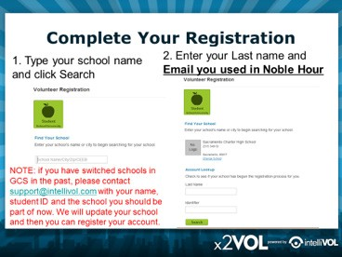

  - Your First Name should appear in the first field on the next page.

  - TYPE IN YOUR STUDENT ID in the third field next to your last name. (if there is an email there, remove it and add your Student ID)

  - Enter your address and a phone number in the Home Phone field.

  - See your email populated and click proceed.

  - Set your interests and skills and click proceed.

  - Set your password, select your group and check the required boxes to complete your registration.

  - Log in and view your Dashboard.

IMPORTANT NOTE: if you have switched schools in the past in GCS, please contact support@intellivol.com with your first and last name and the GCS schools you’ve attended. We will have to confirm your school is accurate in our system before you can register.

If you have ANY issues registering, please contact support@intellivol.com or
866-906-6400 and we will be glad to assist you!

LOGGING HOURS IN X2VOL

My Hours were denied, what do I do?
If your Service-Learning Program Coach denies your hours for any reason, you will receive an email notifying you the hours have been denied. If they added a comment, you will see that as well.

Editing your entries in x2VOL… You can edit your project entry by going to your Activity Log page and clicking the [Edit] button next to
the entry you wish to edit. You only can edit opportunities that have not been approved by the school yet.

HELP! How to use x2VOL additional videos and instructions: https://myintellivol.desk.com/

- Log in to x2VOL and view your Dashboard.

- Click the green button, [Add Hours].

- You will be on your Activity Log page.

  - If you signed up for an opportunity in x2VOL prior to the event happening, you will see it listed in the bottom section, Community and School Opportunities. Click the [Add Hours] button to log your hours.

  - If you did not sign up for the opportunity in x2VOL, you can log your hours as a Personal Project. Click the blue, [Create New] button in the top section titled Personal Projects.
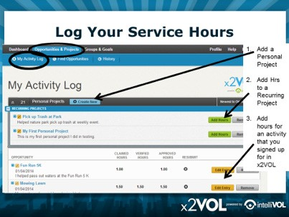

- Every time you log hours, there will be fields to fill out: Activity Name, Project Description, Hours amount, date etc. You can add an attachment if needed.

- Recurring Project: if this project is something you do on a regular basis, make sure you check the box, [Make this a Recurring Project]. It will save to your Activity Log and allow you to just add the hours and dates in the future, instead of logging the entire activity from scratch each time.

- Multiple Dates: if you’ve done a project over the span of multiple dates, you should enter the last date you volunteered and then explain the details of all the dates you served in the description box.

- Goals: please select the proper goals for this project to count towards. You may only have one option to select with all your goals which allow double- dipping.

- Honor Code: you must check the honor code before submitting your hours.
You are claiming that the information you submitted is accurate and true.

DID YOU KNOW…?

…Service-Learning helps students to be more connected to their school and community?

…People who serve as adults are happier, healthier and more satisfied with their lives?
Some things to think about as you participate in service-learning:

You will represent your family and school.
Do it with integrity by presenting yourself in appropriate attire and being well- groomed.

Use appropriate language with children, the elderly, animals, etc.

Listen respectfully and follow all directions.
These are important social skills in future careers and in life.

Honor all time commitments you make.
This is a life skill you will need in any career you choose.

Be prepared with whatever materials you need.
(Notebook, pencil, sweater, gloves, your Service-Learning Log, etc.)

Ask questions or clarify tasks when you are unclear of what is expected of you. Show character and honesty in all service-learning situations.
Keep an accurate Service-Learning Student Log.
Without a confirmation, you won’t get credit for your hours of service.

Some of your teachers may offer service-learning hours related to their course. Remind them to register the service-learning experience with the number of hours each student has completed per each service-learning experience. (And be sure you keep a log of your hours of service.)

Source: Adapted from the Long Beach Unified School District Student Service-Learning Manual


In compliance with federal laws, Guilford County Schools administers all educational programs, employment activities and admissions without discrimination because of race, religion, national or ethnic origin, color, age, military service, disability or gender, except where exemption is appropriate and allowed by law. Refer to the Board of Education’s Discrimination Free Environment Policy AC for a complete statement. Inquiries or complaints should be directed to the Guilford County Schools Compliance Officer, 120 Franklin Blvd., Greensboro, NC 27401; 336-370-2323.

